**NALAIYA THIRAN PROJECT BASED LEARNING ON PROFESSIONAL READLINESS FOR INNOVATION, EMPLOYNMENT AND ENTERPRENEURSHIP**

**Personal Expense Tracker Application**

**A PROJECT REPORT**

**DEEPTHI P (190701265)**

**NIVETHA B (190701130)**

**NESIGAN M L (190701127)**

**PRASEETHA P (190701144)**

**BACHELOR OF ENGINEERING IN COMPUTER SCIENCE**

**AND ENGINEERING**

**RAJALAKSHMI ENGINEERING COLLEGE, CHENNAI.**

**INDEX**

1. **INTRODUCTION** 
   1. Project Overview

1.2Purpose

1. **LITERATURE SURVEY**
   1. Existing problem
   2. References
   3. Problem Statement Definition
2. **IDEATION & PROPOSED SOLUTION**
   1. Empathy Map Canvas
   2. Ideation & Brainstorming
   3. Proposed Solution
   4. Problem Solution fit
3. **REQUIREMENT ANALYSIS**
   1. Functional requirement
   2. Non-Functional requirements
4. **PROJECT DESIGN**
   1. Data Flow Diagrams
   2. Solution & Technical Architecture
   3. User Stories
5. **PROJECT PLANNING & SCHEDULING**
   1. Sprint Planning & Estimation
   2. Sprint Delivery Schedule
   3. Reports from JIRA
6. **CODING & SOLUTIONING (Explain the features added in the project along with code)**
   1. Feature 1
   2. Feature 2
   3. Database Schema (if Applicable)
7. **TESTING** 
   1. Test Cases
   2. User Acceptance Testing
8. **RESULTS**
   1. Performance Metrics
9. **ADVANTAGES & DISADVANTAGES**
10. **CONCLUSION**
11. **FUTURE SCOPE**
12. **APPENDIX**

Source Code

GitHub & Project Demo Link

**INTRODUCTION**

**PROJECT OVERVIEW**

Category: Cloud App Development

Team ID: PNT2022TMID02226

**Skills Required:**

IBM Cloud, HTML, CSS, JavaScript, IBM Cloud Object Storage, Python Flask, Kubernetes, Docker, IBM DB2, IBM Container Registry

**Project Description:**

The daily Expense Tracker System is designed to keep a track of the Income Expense of an organization on a day-to-day basis. This System divides the income based on daily expenses. They have an option to set a limit for the amount to be used for that particular month if the limit is exceeded the user will be notified with an email alert. Daily expense tracking System will generate a report at the end of the month to show Income-Expense graph. By using this application, we can reduce the manual calculations of the daily expenses and keep track of the expenditure. Expense management software allows administrators to have full visibility of and track employee use of business financial resources. Expense management software analyzes overall expenses, identifies cost saving opportunities, and controls excessive spending.” Expense Tracker” is developed to manage the daily expenses in a more efficient and manageable way.

**PURPOSE**

Managing pay up then debts has been a true problem for a long time. People are much less in all likelihood in accordance with preserve song about their spending, stand it, in checkbook yet even spreadsheets. Despite that, because of the current decades, it has acquired a latter perspective with the advent of modern 4 technologies yet the internet is turning into extra yet more accessible. For example, like how much it expenses for monthly and what are the expenses for a month. Some of the expense features like food expenses billing expenses like phone, electricity, taxation and some other personal expense. In this fast-moving world this web application will be very useful for a people who was a family and especially for a business people. Budgeting is an integral part of the society. Budget Tracking involves recording and analyzing the incomes and expenses of a person or an organization over a particular period of time. Daily Expense Tracker helps in accordance with maintain the document regarding daily costs yet month-to-month income because someone person or additionally generates a month-to month file over the expenses. This Project will save time and provide a responsible lifestyle. This system is made and supervised by the experts and satisfying by the user. The expense tracker will help any organization to deal with all their expenses more efficiently. By using software for managing expense tracking will help to control unnecessary expenses. There are several benefits and advantages of using online expense trackers, expense tracking makes any organization run faster and smoother.

**2.LITERATURE SURVEY**

**2.1 EXISTING PROBLEM**

In existing, we need to maintain the Excel sheets, CSV etc. files for the user daily and monthly expenses. In existing, there is no as such complete solution to keep a track of its daily expenditure easily. To do so a personas to keep a log in a diary or in a computer, also all the calculations needs to be done by the user which may sometimes results in errors leading to losses. There can be many disadvantages of using a manual accounting system. Accounting, for any business, can be a complex undertaking. A manual accounting system requires you to understand the accounting process in a way that may be unnecessary with a computerized accounting system. This can be an advantage or a disadvantage, depending on the person doing the bookkeeping; often, a specially trained professional is needed to ensure that accounting is done properly. Unraveling the complexity of your financial records by hand may be time consuming. Since it takes time to generate reports.

**2.2 REFERENCES**

1. “Expense Tracker”, Miriam Thomas, Lekshmi.P, Dr.T.Mahalekshmi , year: 2020

2. “Expenditure management system”, Dr.V.Geetha, G. Nikhitha. Year: 2022

3. “D2D Expense tracker application”, Anjali Kumara, Utkarsh Raj. Year:2021

4. “Tracking Expenses by Commodity at Widget Farmers Cooperative”, Ramasam. Year:2004

5.” Expense tracker” Atiya Kazi, Praphulla.S. year: 2020

**2.3 PROBLEM STATEMENT DEFINITION**

Due to the busy and hectic lifestyle people tend to overlook their budget and end up spending an excessive amount of money since they usually didn’t plan their budget wisely. Therefore, user cannot predict future expenses. While writing down their expenses or managing them in excel spreadsheet, their lack of knowledge in managing finances will be a problem. Personal Expense Tracker helps the user to manage their expenses and aids in overall budgeting. The main objective of this project is support to the user to sustain all financial activities like digital automated dairy. This application helps the user to avoid unexpected expenses and bad financial situations.

**3.IDEATION & PROPOSED SOLUTION**

**3.1 EMPATHY MAP**

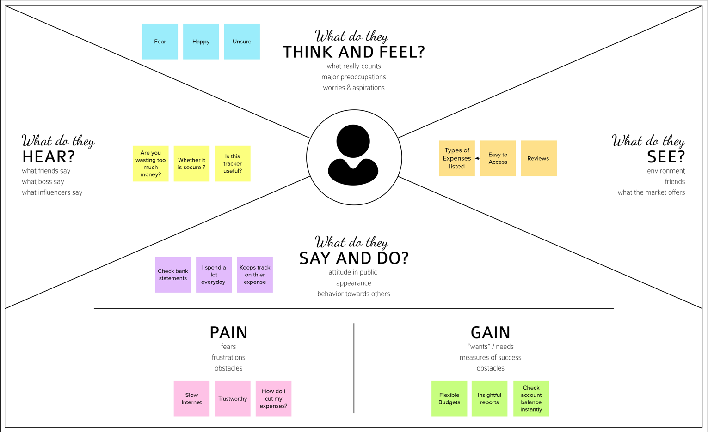

**3.2 IDEA ON & BRAINSTORMING**

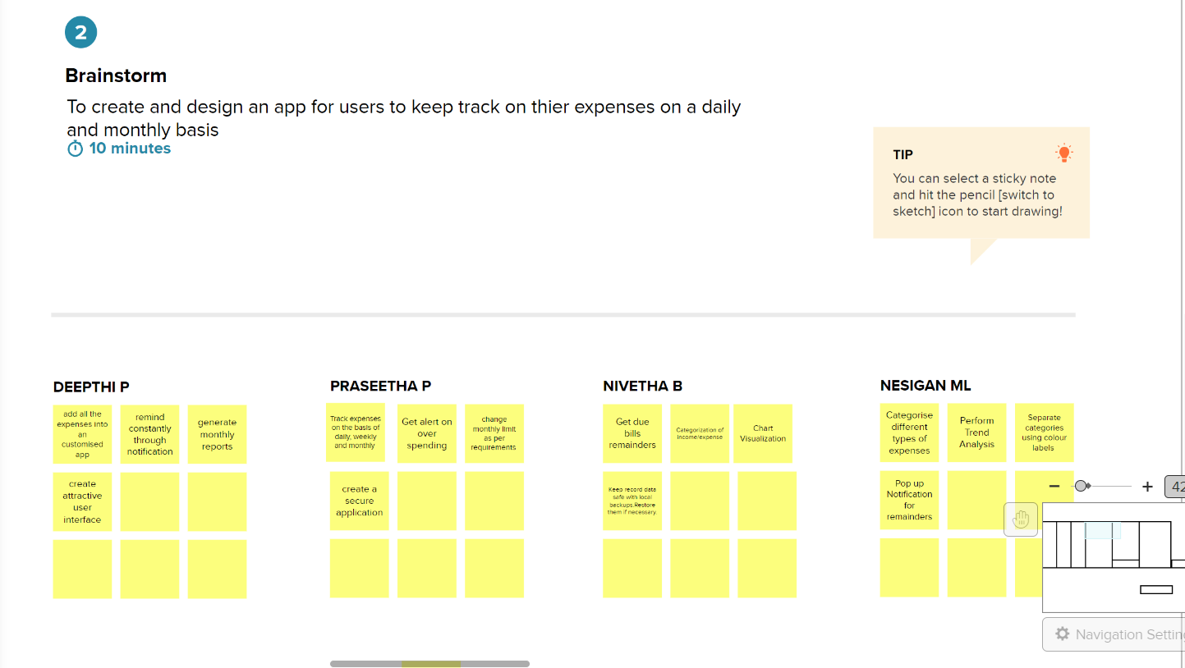

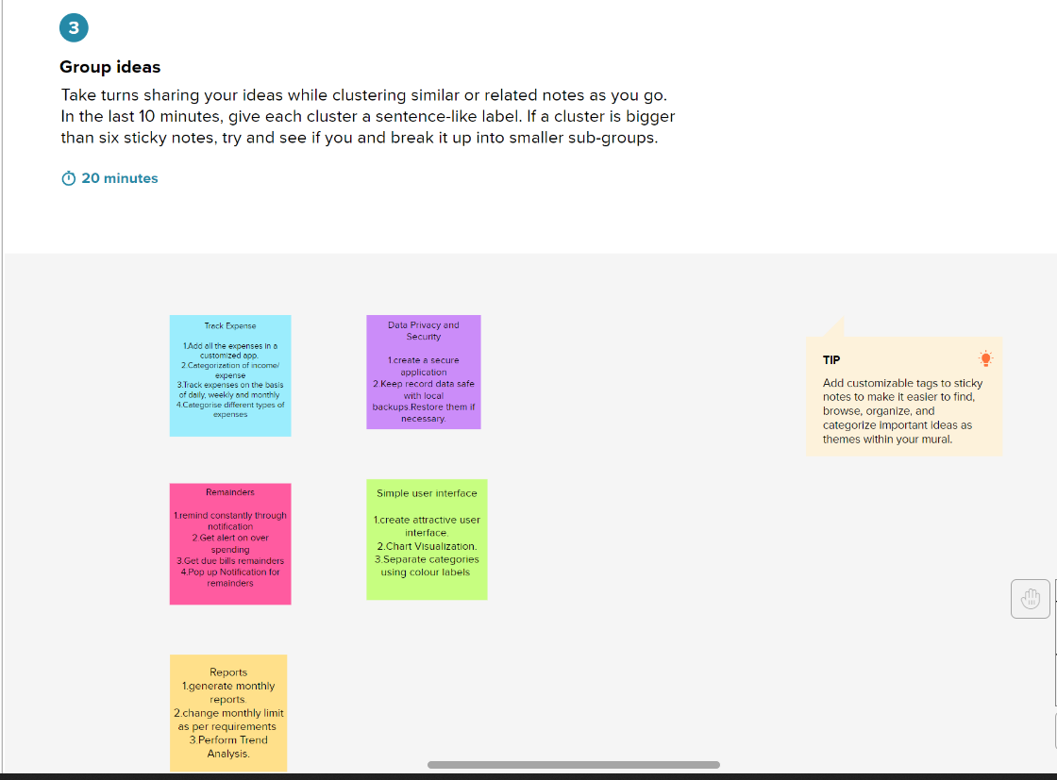

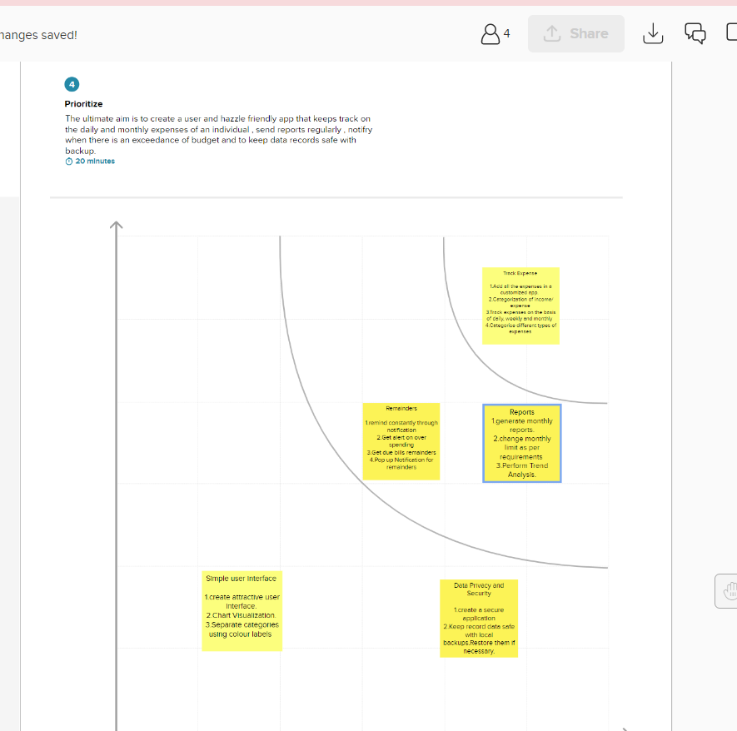

**3.3 PROPOSED SOLUTION**

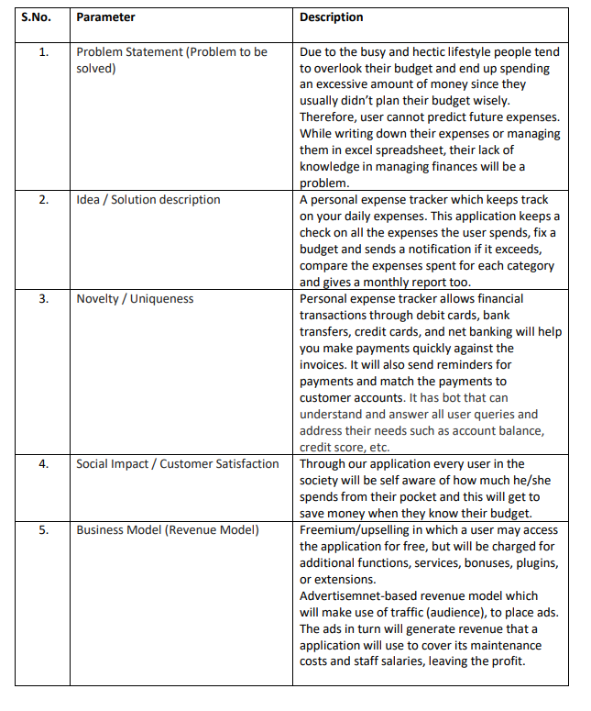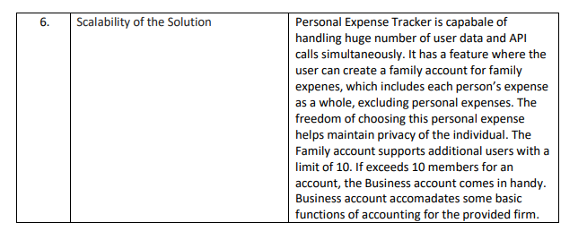

**3.4 PROBLEM SOLUTION FIT**

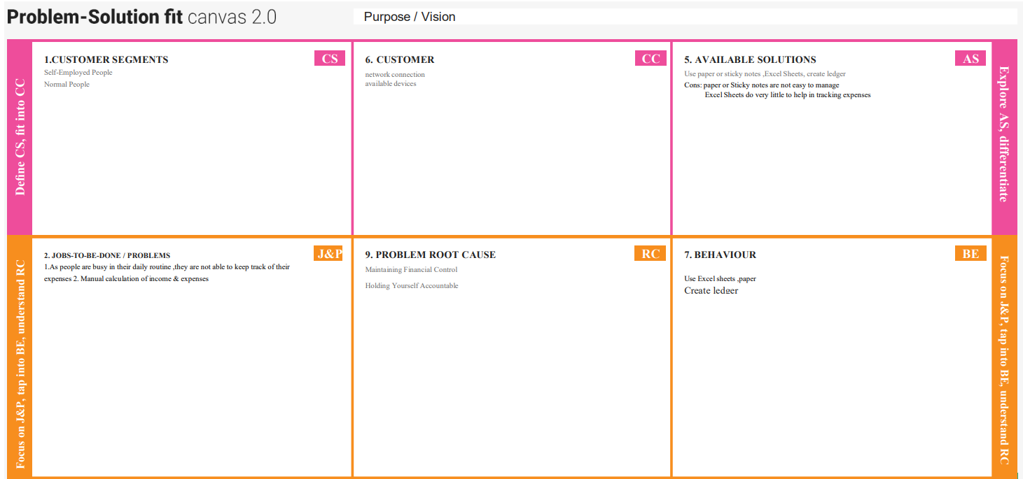

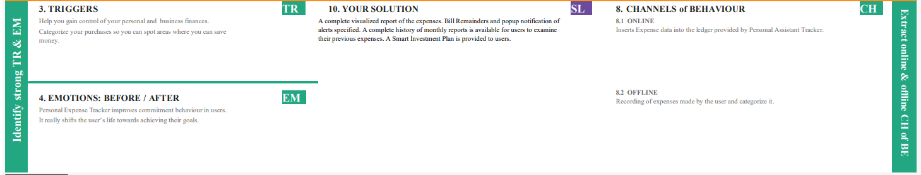

**4.REQUIREMENT ANALYSIS**

**4.1 FUNCTIONAL REQUIREMENT**

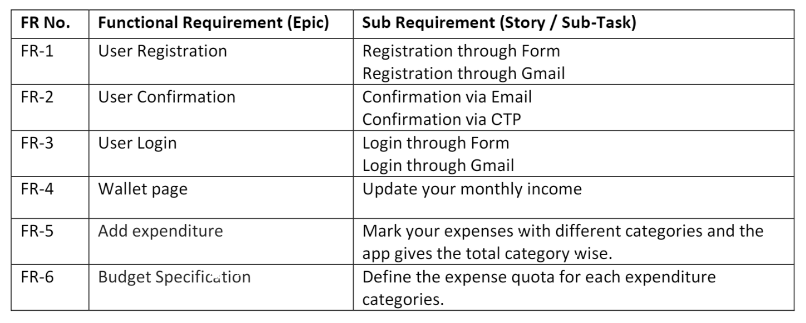

**4.2 NON-FUNCTIONAL REQUIREMENTS**

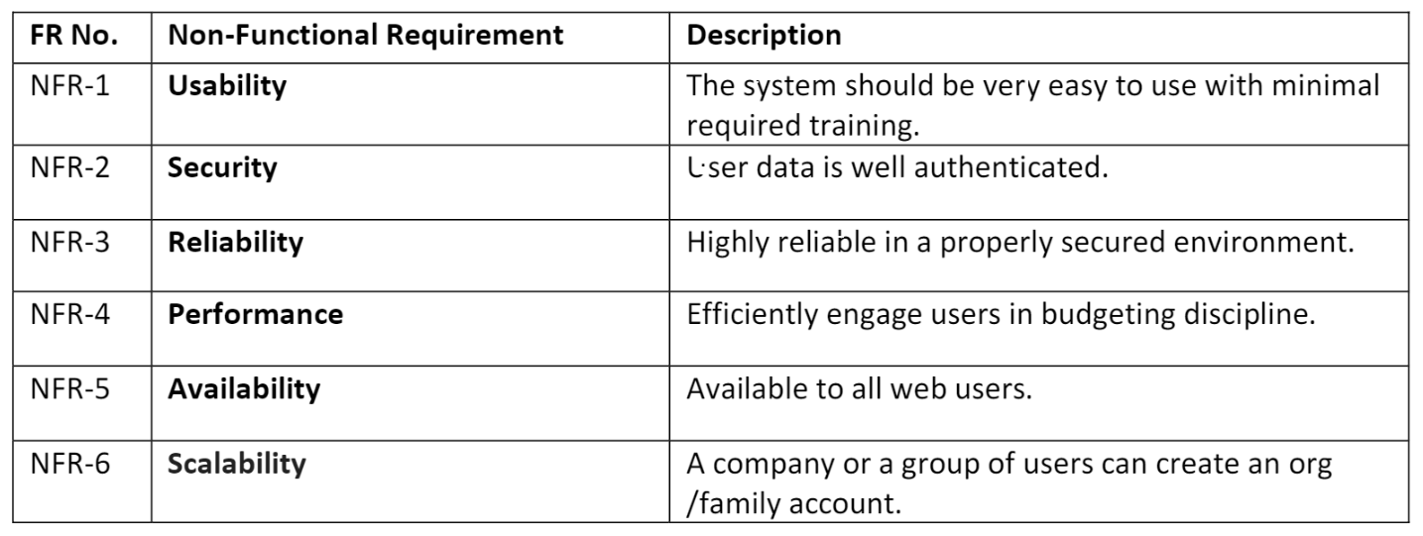

**5.PROJECT DESIGN**

**5.1 DATA FLOW DIAGRAMS**

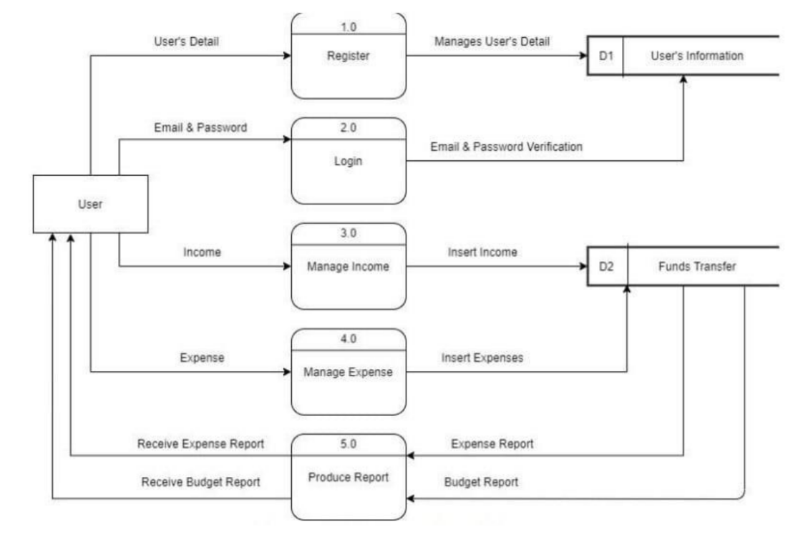

**5.2 SOLUTION & TECHNICAL ARCHITECTURE**

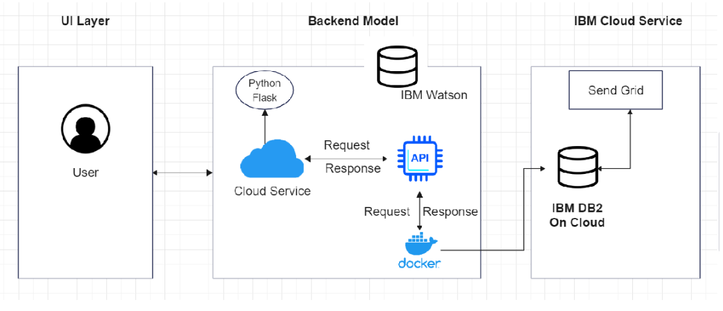

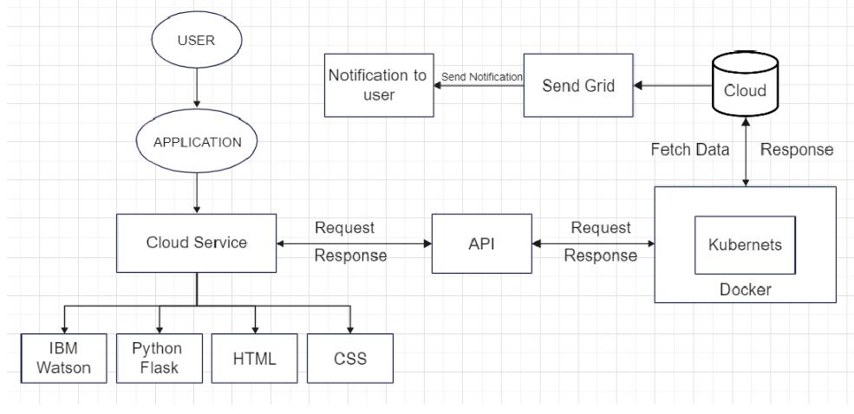

**5.3 USER STORIES**

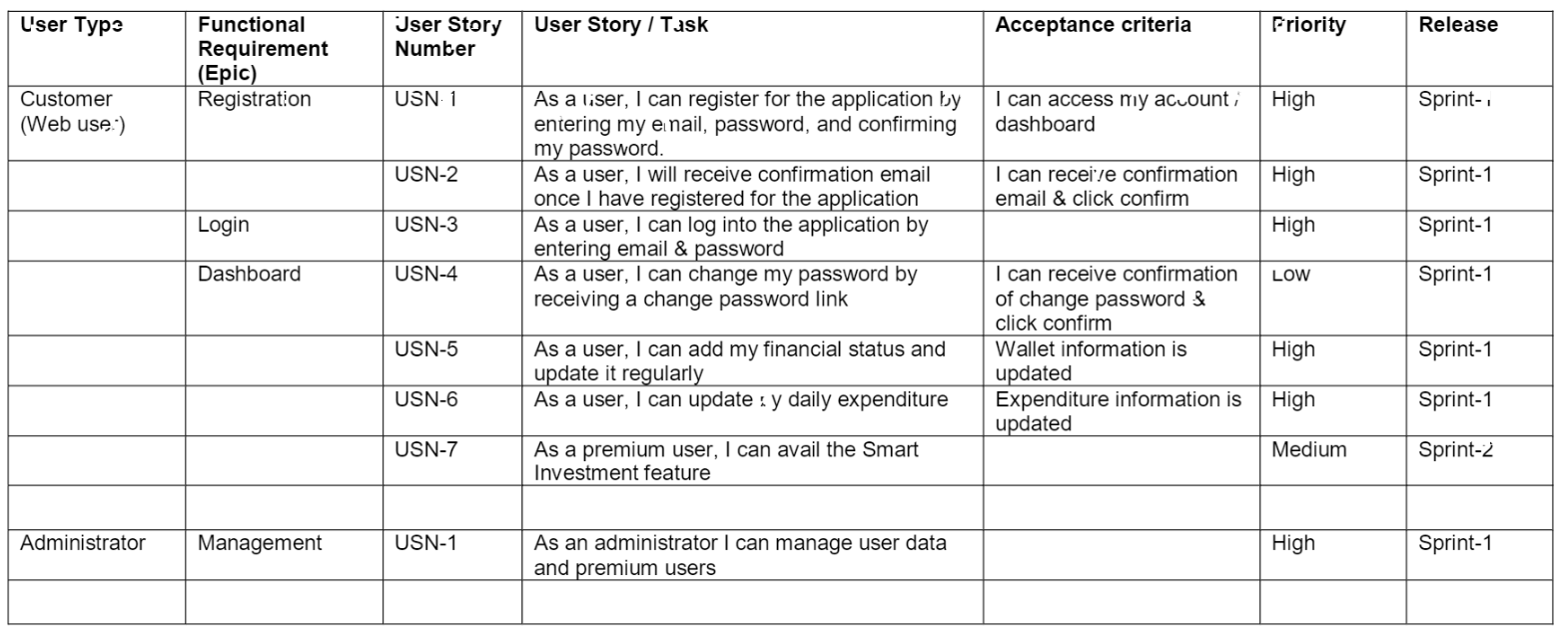

**6.PROJECT PLANNING & SCHEDULING**

**6.1 SPRINT PLANNING & ESTIMATION**

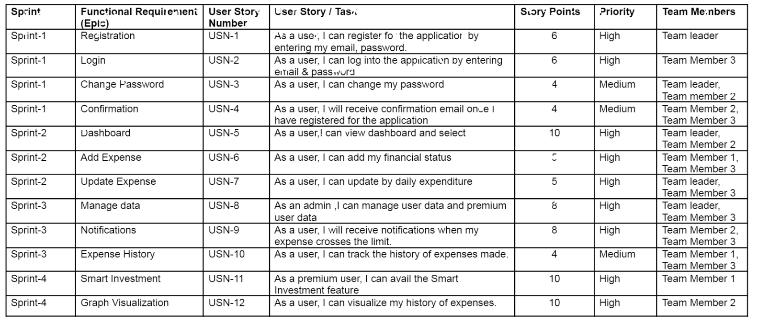

**6.2 SPRINT DELIVERY SCHEDULE**

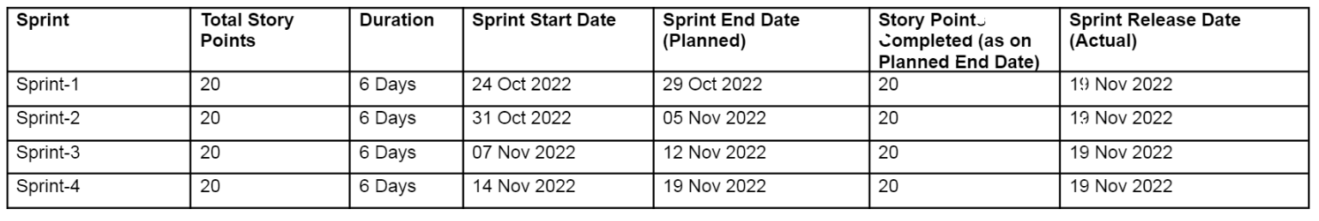

**Velocity:**

Imagine we have a 10-day sprint duration and the velocity of the team is 20 (points per sprint). Let’s calculate the teams average velocity (AV) as per iteration unit (story points per day)

AV = Sprint duration/velocity = 20/10 = 2

AV = 20/6 = 3.3333…

Sprint 1(AV) **=** 3.34

Sprint 2(AV) **=** 3.34

Sprint 3(AV) **=** 3.34

Sprint 4(AV) **=** 3.34

**Burndown Chart:**

A burndown chart is a graphical representation of work left to do, reduces time. It often used in agile software development methodologies such as scrum. However, burn down charts can be applied to any project containing measurable progress over time.

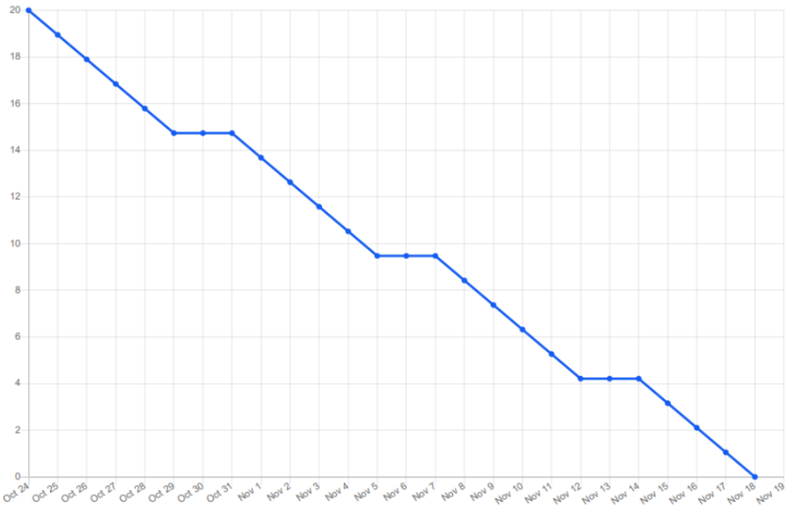

**6.3 REPORTS FROM JIRA**

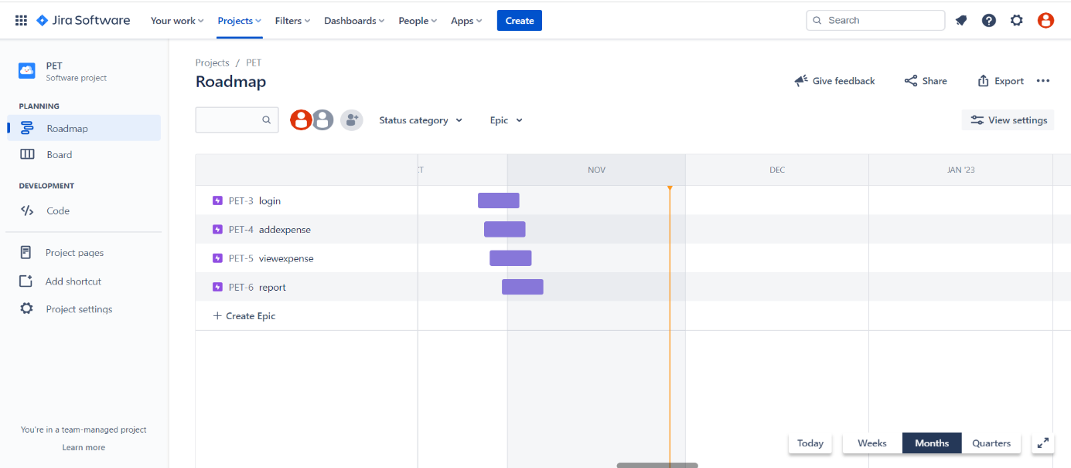

**7. CODING & SOLUTIONING**

**7.1 Feature 1**

- **Login.html**

<!DOCTYPE html>

<html lang="en" dir="ltr">

   <head>

      <meta charset="utf-8">

      <title>Personal Expense Tracker</title>

      <link rel="stylesheet" href="{{ url_for('static', filename='css/style.css') }}">

      <meta name="viewport" content="width=device-width, initial-scale=1.0">

   </head>

   <body>

      <div class="wrapper">

         <div class="title-text">

            <div class="title login">

               Login Form

            </div>

            <div class="title signup">

               Signup Form

            </div>

         </div>

         <div class="form-container">

            <div class="slide-controls">

               <input type="radio" name="slide" id="login">

               <input type="radio" name="slide" id="signup">

               <label for="login" class="slide login">Login</label>

               <label for="signup" class="slide signup">Signup</label>

               <div class="slider-tab"></div>

            </div>

            <div class="form-inner">

               <form action="#" class="login">

                  <div class="field">

                     <input type="text" placeholder="Email Address" name="email" required>

                  </div>

                  <div class="field">

                     <input type="password" placeholder="Password" name = "password" required>

                  </div>

                  <div class="pass-link">

                     <a href="#">Forgot password?</a>

                  </div>

                  <div class="field btn">

                     <div class="btn-layer"></div>

                     <input type="submit" value="Login">

                  </div>

                  <div class="signup-link">

                     Not a member? <a href="">Signup now</a>

                  </div>

               </form>

               <form action="http://localhost:8080/IP/A" method="post"class="signup">

                  <div class="field">

                     <input type="text" placeholder="Email Address" name = "email" required>

                  </div>

                  <div class="field">

                     <input type="password" placeholder="Password" name = "password" required>

                  </div>

                  <div class="field">

                     <input type="password" placeholder="Confirm password" name = "cpassword" required>

                  </div>

                  <div class="field btn">

                     <div class="btn-layer"></div>

                     <input type="submit" value="Signup">

                  </div>

               </form>

            </div>

         </div>

      </div>

      <script>

         const loginText = document.querySelector(".title-text .login");

         const loginForm = document.querySelector("form.login");

         const loginBtn = document.querySelector("label.login");

         const signupBtn = document.querySelector("label.signup");

         const signupLink = document.querySelector("form .signup-link a");

         signupBtn.onclick = (()=>{

           loginForm.style.marginLeft = "-50%";

           loginText.style.marginLeft = "-50%";

         });

         loginBtn.onclick = (()=>{

           loginForm.style.marginLeft = "0%";

           loginText.style.marginLeft = "0%";

         });

         signupLink.onclick = (()=>{

           signupBtn.click();

           return false;

         });

      </script>

   </body>

</html>

**AddExpense.html**

{% extends "layout.html" %}

{% block styles %}

        <link href="/static/css/expenses.css" rel="stylesheet">

{% endblock %}

{% block title %}

    Add Expenses

{% endblock %}

{% block main %}

    <h1>Add Expenses</h1>

    <br>

    <p><small>Tip: Delete a row by clicking/tapping the row number in the '#' column and then clicking/tapping the 'Delete Row' button. Must have at least 2 rows.</small></p>

    <form action="/addexpenses" method="post" id="expenseForm" autocomplete="off">

        <input type="hidden" name="csrf_token" value="{{ csrf_token() }}" />

        <div class="table-responsive-sm">

        <table id="expenseTable" class="table table-hover">

          <thead>

            <tr>

              <th scope="col">#</th>

              <th scope="col">Description</th>

              <th scope="col">Category</th>

              <th scope="col">Date</th>

              <th scope="col">Payer</th>

              <th scope="col">Amount</th>

            </tr>

          </thead>

          <tbody>

            <tr>

              <td onclick="selectRow(this);">1 <i class="far fa-hand-pointer"></i><br>

              </td>

              <td>

                  <textarea class="form-control-sm" name="description.1" form="expenseForm" required maxlength="200" autofocus></textarea>

              </td>

              <td>

                  <select id="category" class="form-control-sm" name="category.1" form="expenseForm" required>

                    {% for category in categories %}

                      <option value="{{ category['name'] }}">{{ category['name'] }}</option>

                    {% endfor %}

                  </select>

              </td>

              <td>

                  <input type="date" class="form-control-sm" name="date.1" form='expenseForm' required value="{{ date }}">

              </td>

              <td>

                  <select class="form-control-sm" name="payer.1" form="expenseForm" required>

                    <option value="Self">Self</option>

                    {% for payer in payers %}

                    <option value="{{ payer['name'] }}">{{ payer['name'] }}</option>

                    {% endfor %}

                  </select>

              </td>

              <td>

                  <!-- Modified RegEx from Gary @ StackOverflow: https://stackoverflow.com/a/16242575 -->

                  <!-- TODO: change input type from 'text' to 'number' to remove the need for regex? Look at my implementation on budgets.html and use the same thing here -->

                  <input type="text" class="form-control-sm" name="amount.1" form='expenseForm' size="10" placeholder="$" required maxlength="10" pattern="(?=.*?\d)^(([1-9]\d{0,2}(\d{3})*)|\d+)?(\.\d{1,2})?$" title="Format must be currency value without dollar sign or commas e.g. 1, 2.50, 1500.75">

              </td>

            </tr>

          </tbody>

        </table>

        </div>

        <br>

        <button type="button" id="btnNewRow" class="btn btn-primary" onclick="addRow();">New Row</button>

        <button type="button" id="btnDeleteRow" class="btn btn-danger" onclick="removeRow(selectedRow);" disabled>Delete Row</button>

        <button type="submit" id="btnExpense" class="btn btn-success">Save</button>

    </form>

    <br>

    <script src="/static/js/addexpenses.js"></script>

    <script>

      var categoryData = JSON.stringify({{ categories | tojson }});

      var dateData = "{{ date }}";

      var payersData = JSON.stringify({{ payers | tojson }});

      loadData(categoryData, dateData, payersData);

    </script>

{% endblock %}

**Database:**

CREATE FUNCTION FUNCTION1 (VARNAME VARCHAR(128))

RETURNS INTEGER

NO EXTERNAL ACTION

F1: BEGIN ATOMIC

-- #####################################################################

-- # Returns count of all tables created by and VARNAME

-- #####################################################################

RETURN

SELECT COUNT(*)

FROM SYSIBM.SYSTABLES

WHERE CREATOR = '' AND NAME = VARNAME@INNER_TERMINATOR

END@OUTER_TERMINATOR

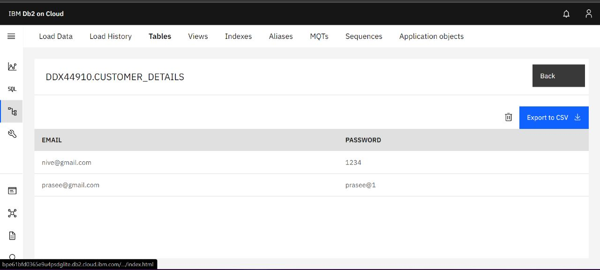

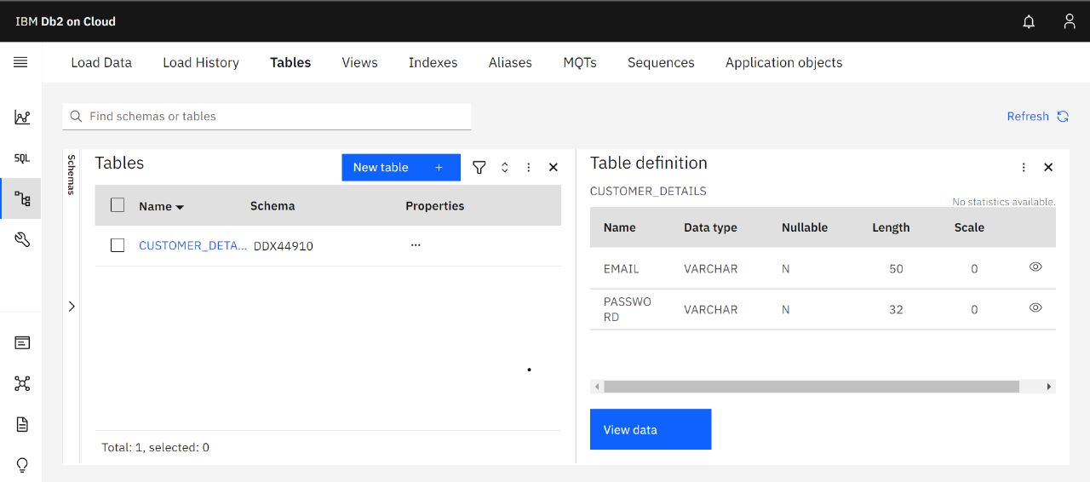

**9. RESULTS**

● Reports:

The expense tracking app generates and sends reports to give a detailed insight about profits, losses, budgets, income, balance sheets, etc.,

● Access control:

Increase your team productivity by providing access control to particular users through custom permissions.

● Track Projects:

Determine project profitability by tracking labor costs, payroll, expenses, etc., of your ongoing project.

● Latency: Personal Expense Tracker application deployed on the IBM Kubernetes Cluster offers up to 150 - 200ms in the average traffic and 200 -250ms in the stressed loaded environment with Ngnix container acting as the service in the cluster.

●No. of Failures: Personal Expenses Tracker Application is designed in such a way that it can handledifferent input and respond accordingly. The application is aggressively tested with different test cases so that it reduces the rate of failure up to 0.75%

**10. ADVANTAGES AND DISADVANTAGES ADVANTAGES:**

**Advantage:**

1.Improved visibility: Most expense management software includes a dashboard that compiles employee expense data and presents it in an easy-to-understand visual format using charts and other graphics.

2.Security: All the Data’s are stored in ibm cloud and db2 so all the data are maintained safely.

3.Month wise Comparison: Using the Expense Manager, you can easily make month on month comparisons of earning, expenses and spending in a more organized manner.

4.Alert Mail: User Receives the alert mail when they exceed the expense limit.

5.Automation: All the calculations are automated. Graph are generated based on the expense made.

6.User Friendly: Expenses can be added easily.

**Disadvantages:**

The financial aspect of an individual can be a important data which can harnessed both on advantageous and disadvantageous manner. The users can be exploited based on their economical behavior and the unauthorized access to others financial information can be critical violation to the privacy.

**11. CONCLUSION**

Daily Expense Tracker is a gadget that being developed to help customers in budget planning. It offers end customers to file their earnings and costs within the finances that have been planned beforehand. Furthermore, customers are capable to hold song on their spending so they are not wasting their money barring doubt. Last however clearly not the least, they are able to get right of entry to the gadget anytime and anywhere that. After making this application we guarantee that this software will assist its customers to manipulate the value of their daily expenditure. It will show to be beneficial for the human beings who are pissed off with their dayby-day price range management, because of amount of costs and needs to control cash and to preserve the report of each day fee which may also be useful to trade their way of spending money. In short, this application will help its customers to overcome the wastage of money.

**12. FUTURE SCOPE:**

1.User can able to upload the receipt of their expenses made.

2.Application will make suggestion to reduce unnecessary expense.

3.User get remainder in email to add their daily expense.

4.User can able to link bank accounts with our application.

**13.APPENDIX:**

GitHub Source code link:

[**https://github.com/IBM-EPBL/IBM-Project-23379-1659881406**](https://github.com/IBM-EPBL/IBM-Project-23379-1659881406)